Chapter 12, Problem 87.

Consider the single-phase three-wire system shown in Fig. 12.78. Find the current in the neutral wire and the complex power supplied by each source. Take V_{s} as a 115∠0° -V, 60-Hz source.

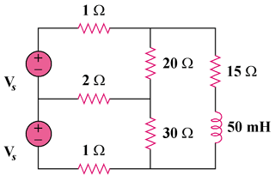

Figure 12.78
For Prob. 12.87.

